**DBMS Assignment 3**

**PESUVariance - Learn, Grow & Challenge Yourself!**

**Team ID: H1**

**Names and respective SRN’s:**

**Shrikar Madhu: PES1UG19CS470**

**Sravya Yepuri: PES1UG19CS502**

**Sri Ramya Priya Vedula: PES1UG19CS504**

**Yousha Mahamuni: PES2UG19CS468**

**Semester: 5, Section: H**

**Simple Queries:**

1. **Retrieve the user activities of student user with User ID as S1. (User)**

SELECT user_id, activity FROM user_profile WHERE user_id = 'S1';

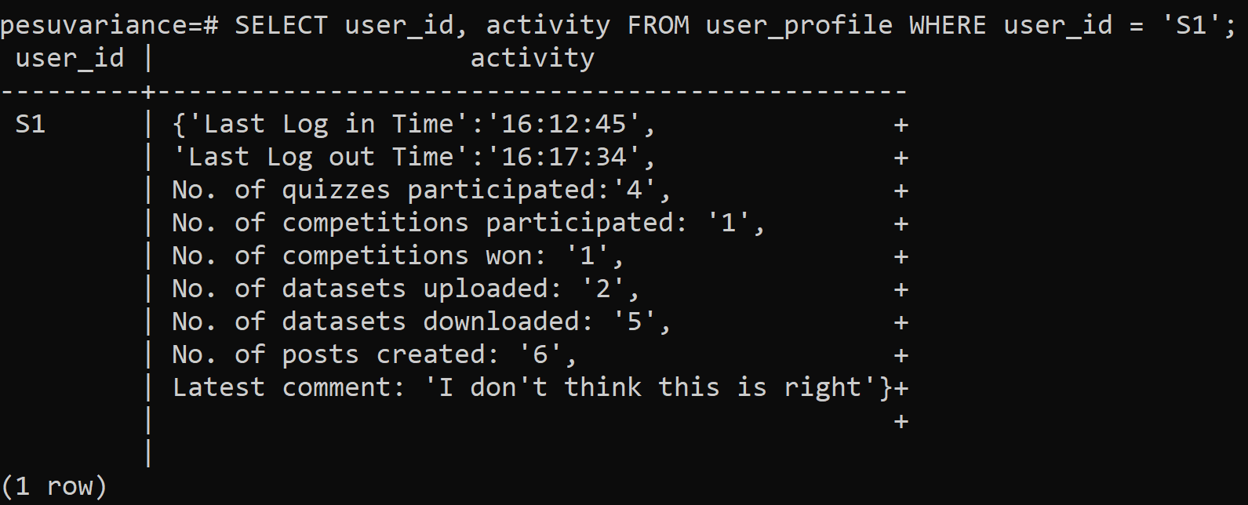

1. **Show the login date and time for a user with username as anjali. (Login)**

SELECT login_username, login_date, login_time FROM login WHERE login_username = 'anjali';

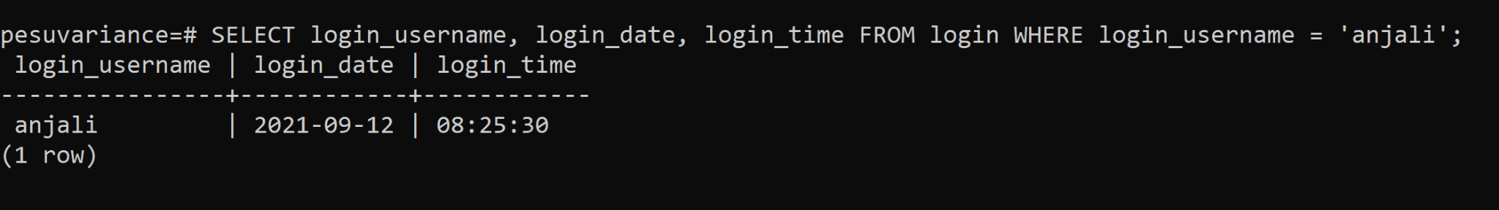

1. **Get all the details of the dataset where the name of the dataset has the word ‘Data’ in it. (Dataset)**

SELECT dataset_id, dataset_userid, dataset_name, dataset_owner, description, size, dateset_date, dataset_time FROM dataset WHERE dataset_name LIKE '%Data%';

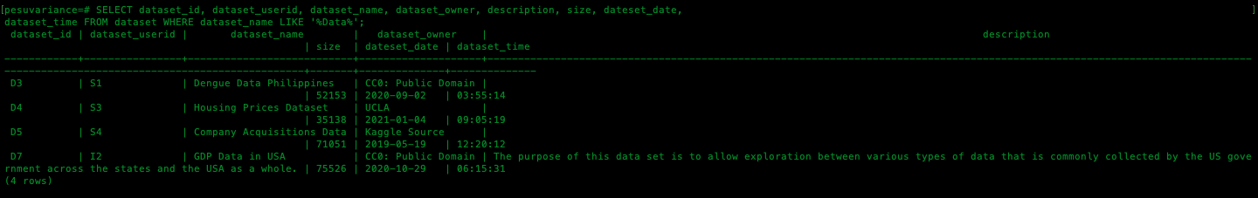

1. **Retrieve the Competition ID and number of entries for each hacking competition. (Competitions)**

SELECT c_competition_id, c_competetion_name, c_no_of_entries FROM competitions WHERE c_competetion_name LIKE '%HACK%';

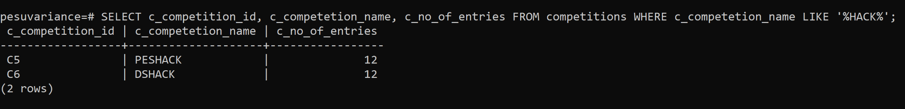

1. **Get the number of questions in a quiz which has its complexity as hard. (Quiz)**

SELECT quiz_name, no_questions, complexity FROM quiz WHERE complexity = 'Hard';

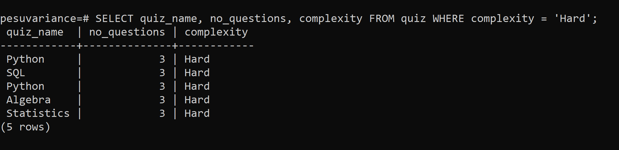

1. **Post owners with the posts in between some time. (Post)**

SELECT post_id, post_title, post_owner, post_desc, p_date FROM post WHERE p_date BETWEEN '2020-04-09' AND '2020-09-30';

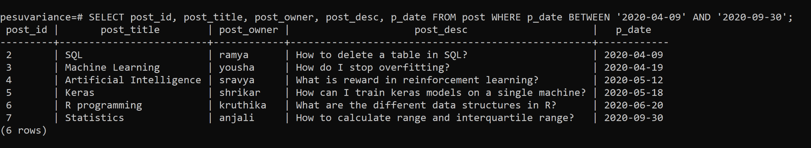

**Complex & Nested Queries:**

1. **Get the names of the competitions being participated in by a particular user (Competitions)**

CREATE TABLE temp_participated_by AS select * from participated_by;

SELECT * FROM temp_participated_by;

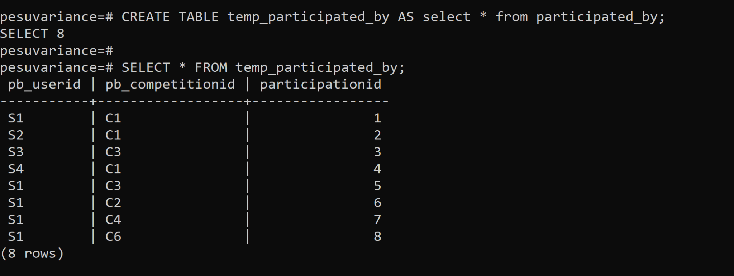

ALTER TABLE temp_participated_by RENAME COLUMN pb_userid TO user_id;

ALTER TABLE temp_participated_by RENAME COLUMN pb_competitionid TO c_competition_id;

SELECT * FROM temp_participated_by;

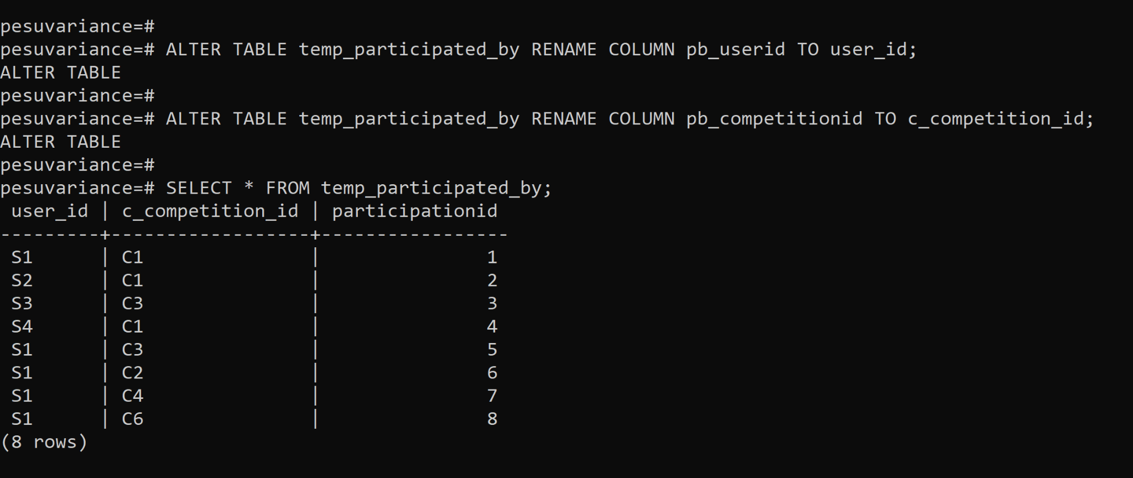

CREATE TABLE temp_participated_by_user AS (SELECT * FROM user_profile NATURAL JOIN temp_participated_by);

CREATE TABLE temp_competitions_participated_by_user AS (SELECT * FROM temp_participated_by_user NATURAL JOIN competitions);

SELECT user_id, name, c_competition_id, c_competetion_name FROM temp_competitions_participated_by_user WHERE user_id = 'S1';

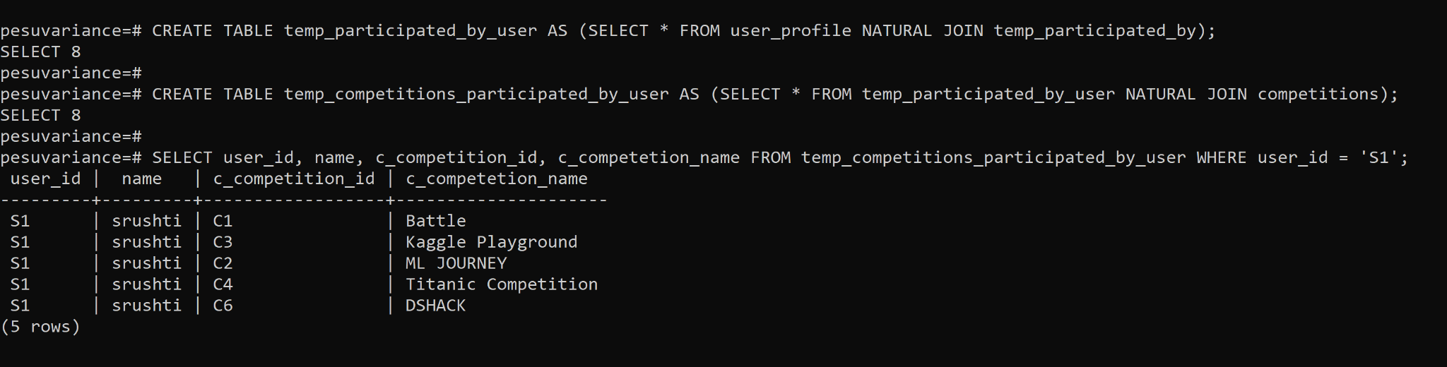

1. **Find the number of downloads and uploads of the datasets by the users who have both uploaded and downloaded.**

CREATE TABLE temp_downloads AS select * from downloads;

ALTER TABLE temp_downloads RENAME COLUMN do_userid TO user_id;

CREATE TABLE temp_user_downloads AS (SELECT * FROM user_profile NATURAL JOIN temp_downloads);

CREATE TABLE temp_user_gb_downloads AS SELECT user_id, COUNT(do_datasetid) AS downloads FROM temp_user_downloads GROUP BY user_id;

select * from temp_user_gb_downloads;

CREATE TABLE temp_uploads AS select * from dataset;

ALTER TABLE temp_uploads RENAME COLUMN dataset_userid TO user_id;

CREATE TABLE temp_user_uploads AS (SELECT * FROM user_profile NATURAL JOIN temp_uploads);

CREATE TABLE temp_user_gb_uploads AS SELECT user_id, COUNT(dataset_id) AS uploads FROM temp_user_uploads GROUP BY user_id;

CREATE TABLE temp_user_downloads_uploads AS (SELECT * FROM (temp_user_gb_downloads NATURAL JOIN temp_user_gb_uploads));

select * from temp_user_downloads_uploads;

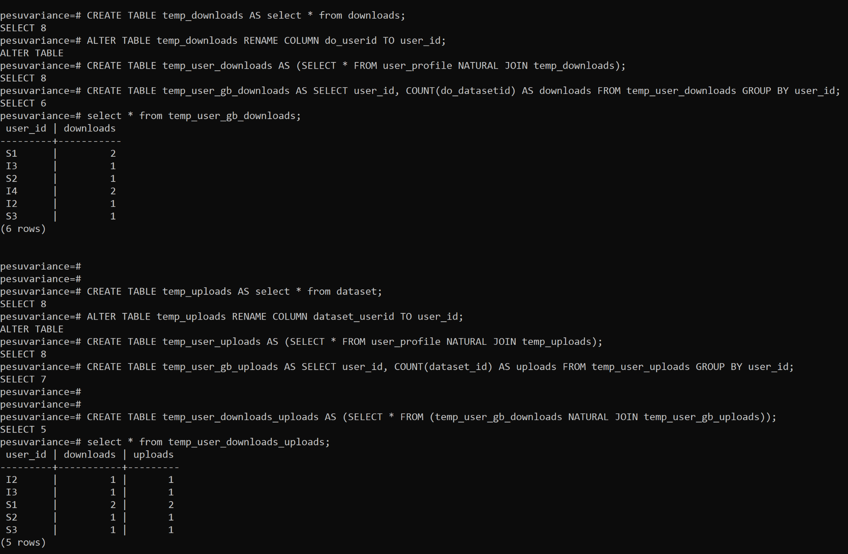

1. **Obtain the submission IDs of ranks 1,2,3 for a particular competition from the leaderboard.**

CREATE TABLE temp_leaderboard AS (SELECT * FROM leaderboard);

ALTER TABLE temp_leaderboard RENAME COLUMN l_competitionid TO c_competition_id;

CREATE TABLE temp_leaderboard_competition AS (SELECT * FROM (temp_leaderboard NATURAL JOIN competitions));

SELECT c_competition_id, c_competetion_name, submission_id, l_rank FROM temp_leaderboard_competition WHERE c_competition_id = 'C1' AND l_rank IN (1, 2, 3);

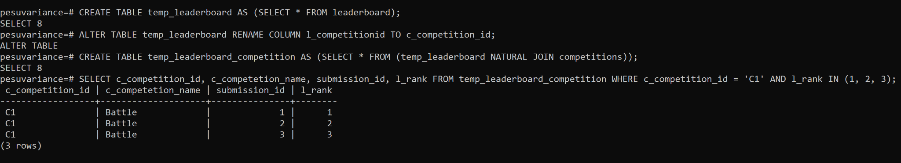

1. **Retrieve the profile picture and user activity of the first user in the database.**

**User_retr.py**

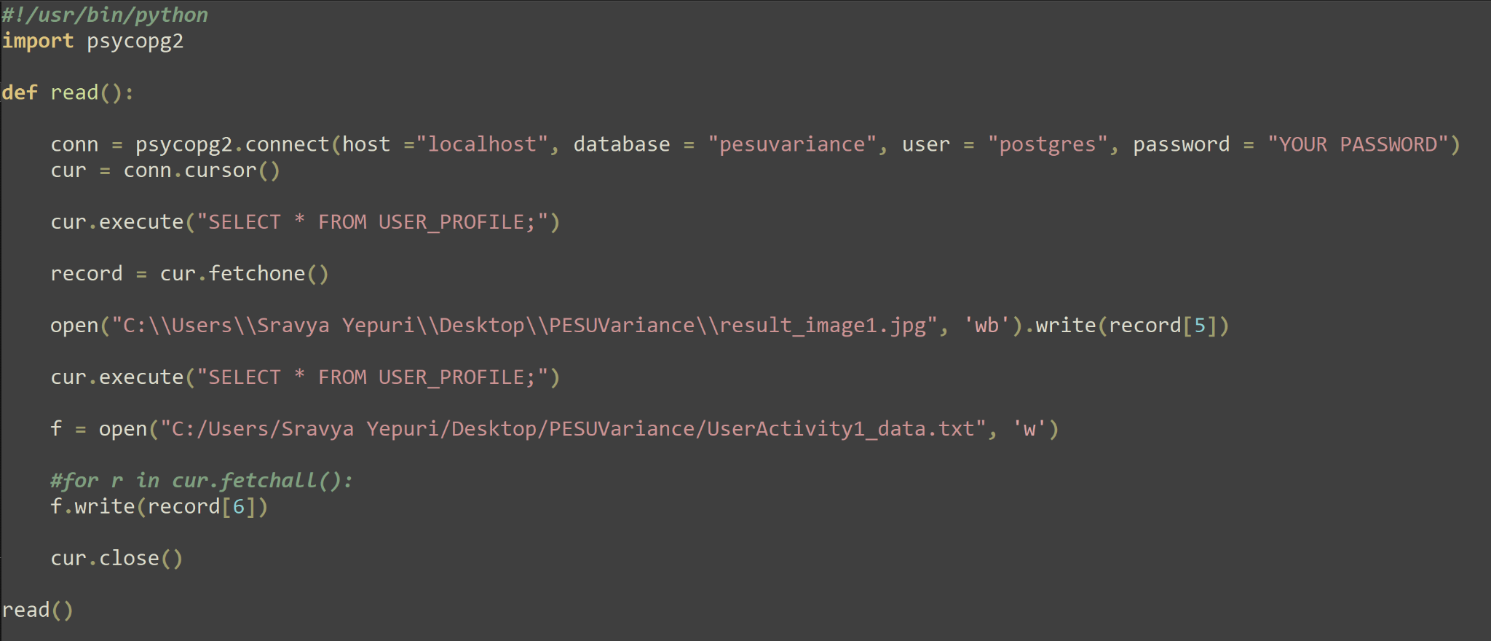

**Files location:**

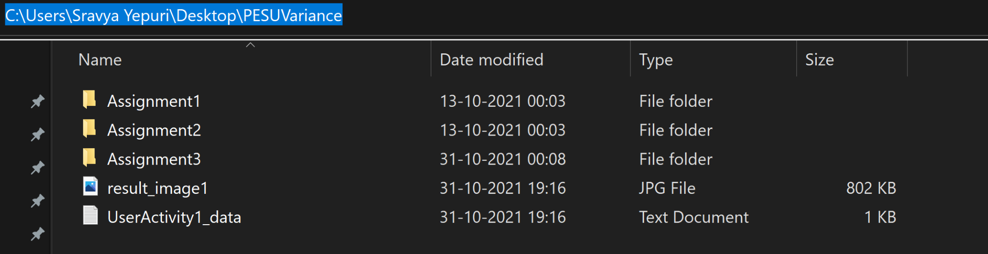

**Result_image1.jpg**



**UserActivity1_data.txt**

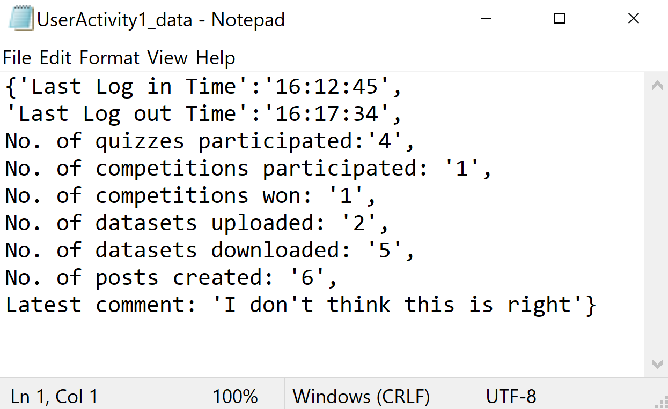

1. **Add comments based on the rank of the teams in the leaderboard using Case..end.**

ALTER TABLE LEADERBOARD ADD COLUMN comments VARCHAR(150);

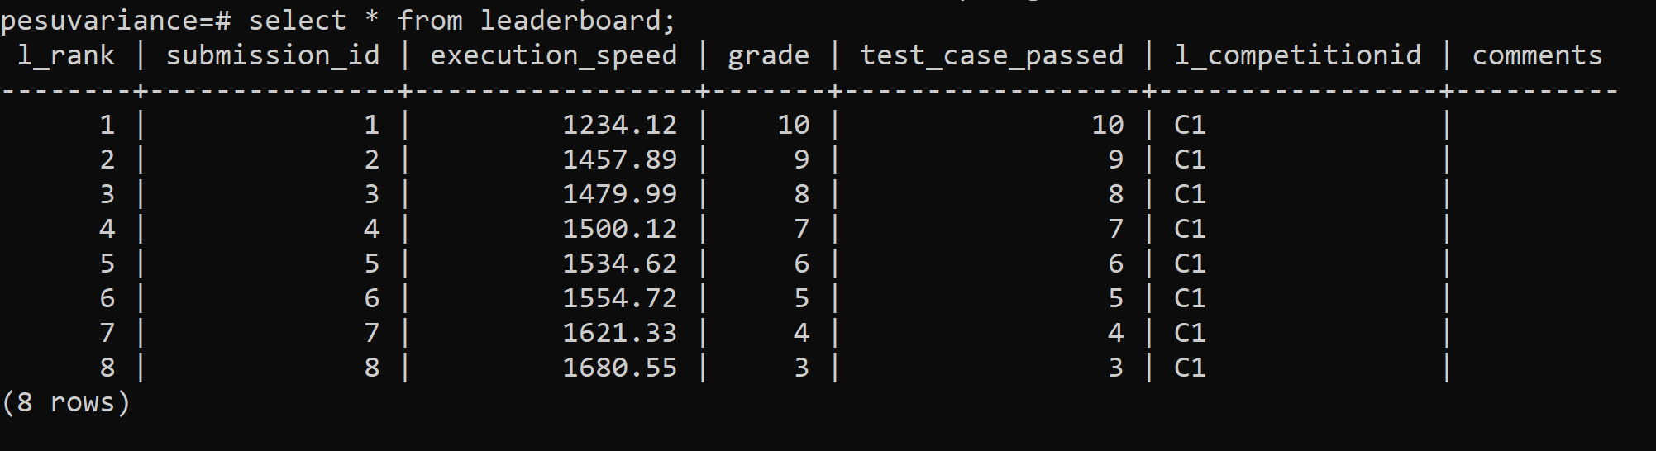

UPDATE leaderboard SET comments = CASE WHEN l_rank <=3 THEN 'Winners' WHEN 5 >= l_rank AND l_rank>3 THEN 'Top Five Finalists' ELSE 'Participants' END;

select * from leaderboard;

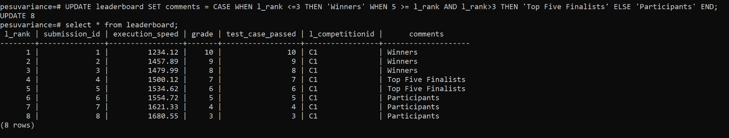

1. **Display submission ids who have execution time lesser than average.**

CREATE TABLE temp_avg_exspeed AS (SELECT AVG(execution_speed) FROM LEADERBOARD);

SELECT * FROM temp_avg_exspeed;

SELECT submission_id, execution_speed FROM LEADERBOARD WHERE execution_speed <= (SELECT * FROM temp_avg_exspeed);

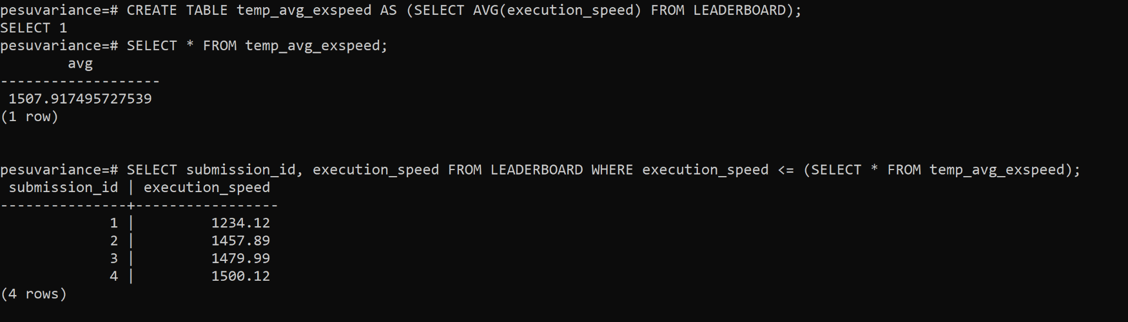

**Access Privileges for users:**

1. **Student**

CREATE USER Student WITH PASSWORD ‘student’ createdb;

GRANT SELECT,UPDATE,INSERT ON TABLE DATASET to Student;

GRANT SELECT ON TABLE Quiz to Student;

GRANT SELECT ON TABLE Questions to Student;

GRANT SELECT,UPDATE,INSERT ON TABLE Competitions to Student;

GRANT SELECT ON TABLE Leaderboard to Student;

GRANT SELECT,UPDATE,INSERT,DELETE ON TABLE POST to Student;

GRANT SELECT,UPDATE,INSERT,DELETE ON TABLE COMMENT to Student;

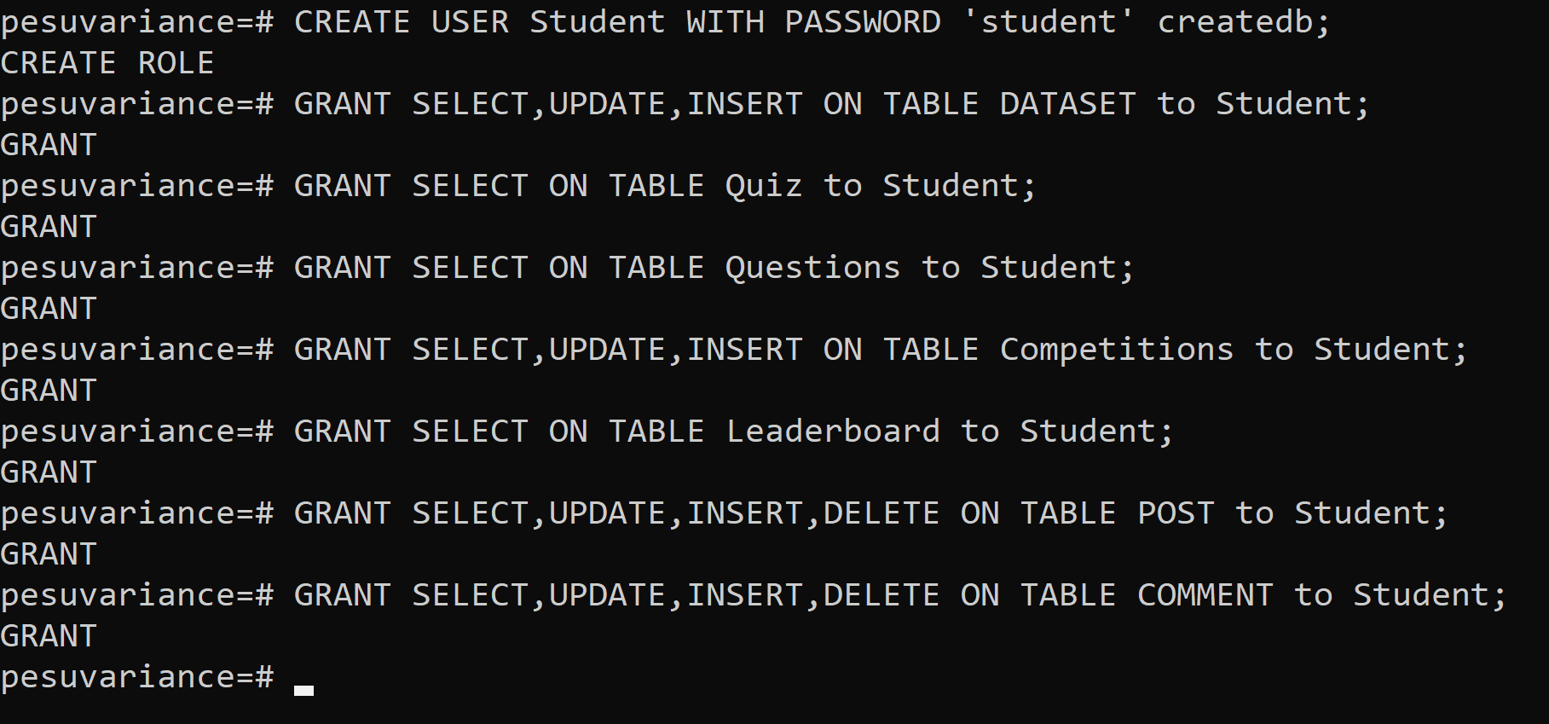

Student Accesses:

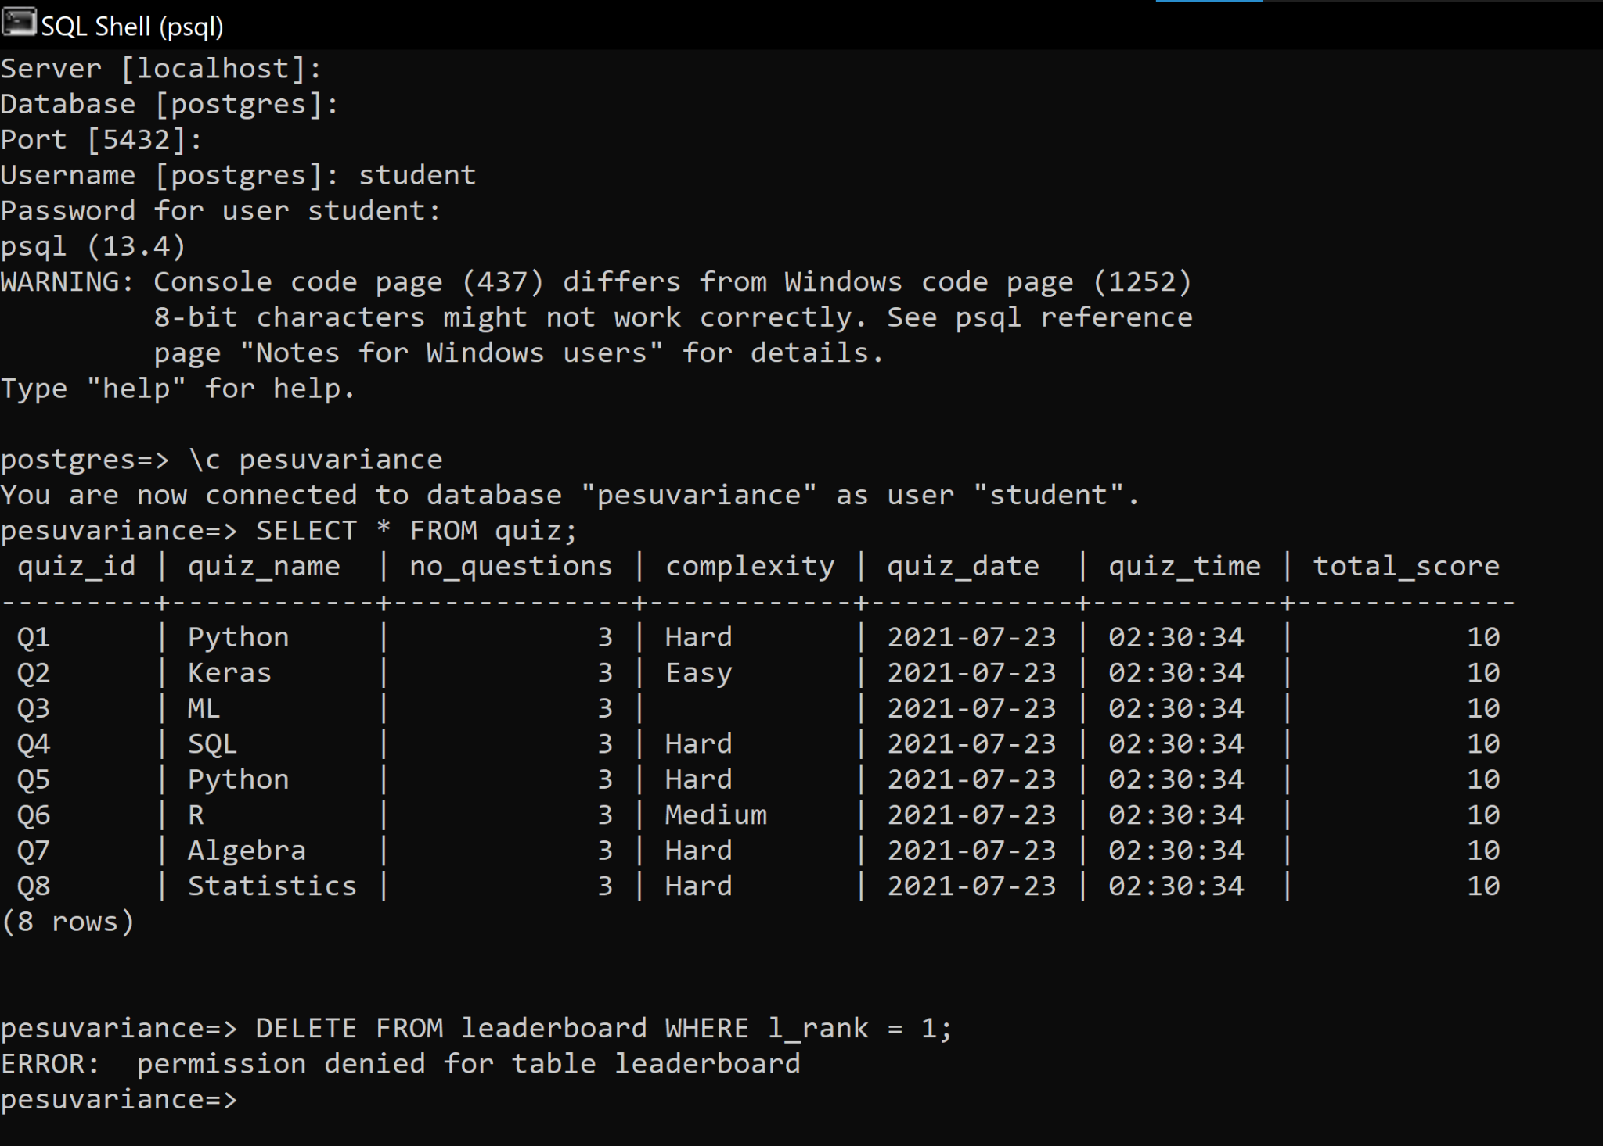

1. **Instructor**

CREATE USER Instructor WITH PASSWORD ‘instructor’ createdb;

GRANT SELECT,UPDATE,DELETE,INSERT ON TABLE DATASET to Instructor;

GRANT SELECT,UPDATE,DELETE,INSERT ON TABLE Quiz to Instructor;

GRANT SELECT,UPDATE,DELETE,INSERT ON TABLE Questions to Instructor;

GRANT SELECT,UPDATE,DELETE,INSERT ON TABLE Answers to Instructor;

GRANT SELECT,UPDATE,INSERT,DELETE ON TABLE Competitions to Student;

GRANT SELECT ON TABLE Leaderboard to Instructor;

GRANT SELECT,UPDATE,INSERT,DELETE ON TABLE POST to Instructor;

GRANT SELECT,UPDATE,INSERT,DELETE ON TABLE COMMENT to Instructor;

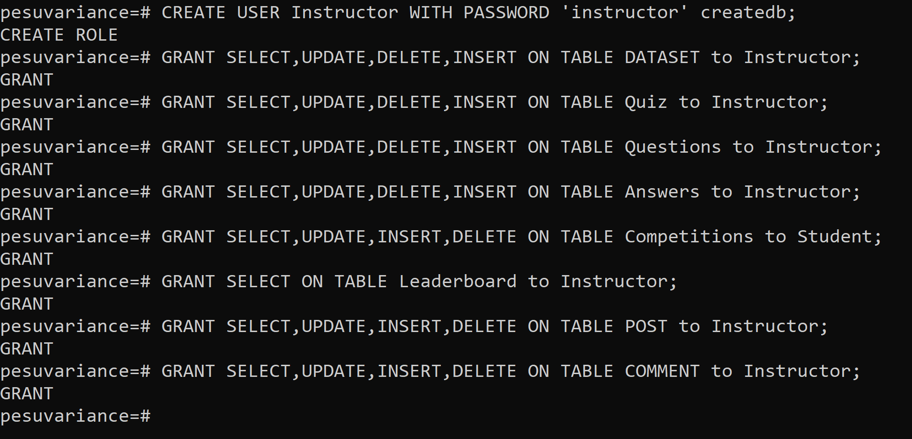

Instructor Accesses:

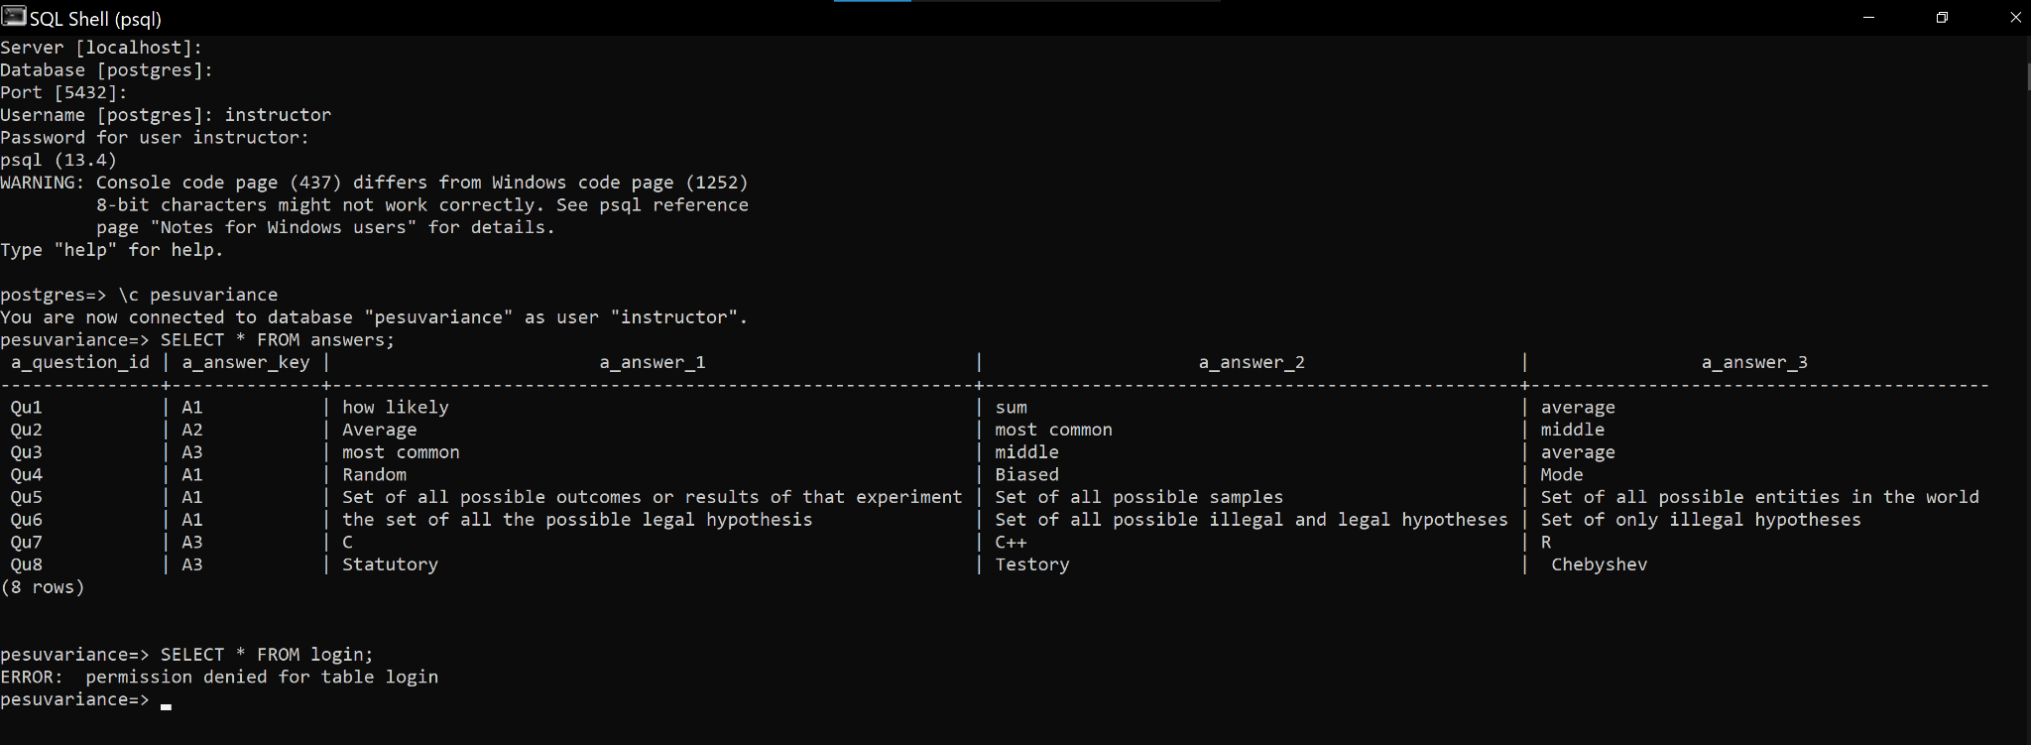

1. **Admin**

CREATE USER Admin WITH PASSWORD ‘admin’ createdb;

GRANT ALL PRIVILEGES ON ALL TABLES IN SCHEMA public TO Admin;

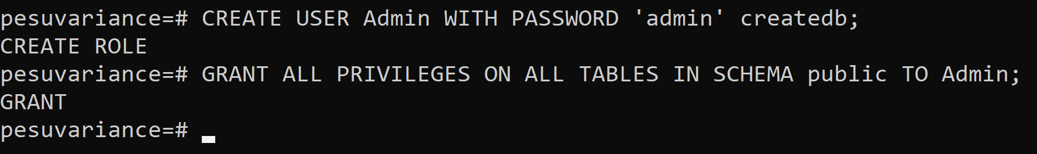

Admin accesses:

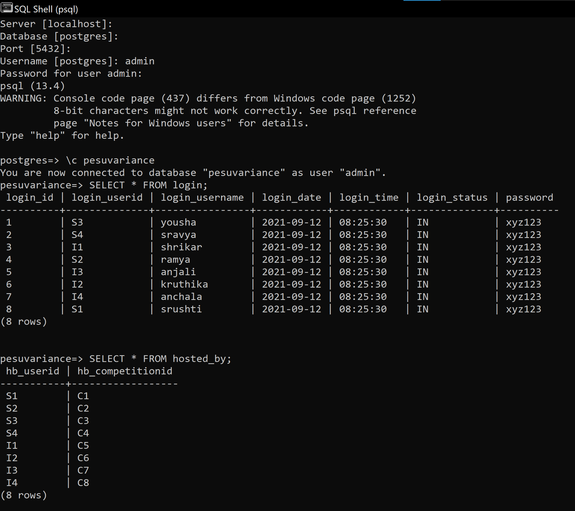

All users:

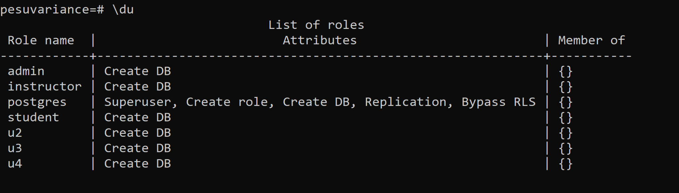

**Contribution of each member:**

Shrikar Madhu - Simple Queries, Complex Queries, Creating roles and granting permissions.  
Sravya Yepuri - Simple Queries, Complex Queries, Creating roles and granting permissions.

Sri Ramya Priya Vedula - Simple Queries, Complex Queries, Creating roles and granting permissions.

Yousha Mahamuni - Simple Queries, Complex Queries, Creating roles and granting permissions.

**Time spent to complete assignment 2:**

Simple queries - 2 Hours

Complex queries - 4 Hours

Access privileges for users - 3 Hours

Making final report - 2 Hours

Google Drive Link:

https://drive.google.com/drive/folders/1c4edDO3BsWH6p0nfCj5TaMz7a0MN7vdl